`

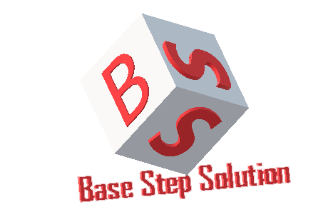

Meeting Minutes

Van Lang Admissions

# Revision Table

|  |  |  |  |
| --- | --- | --- | --- |
| Author | Date | Reason for changes | Version |
| Khoi Nguyen | 25/04/2016 | Initial Document | 1.0 |

Table of Contents

Revision Table 1

I. Purpose 3

II. Participant in meeting 3

III. Content of meeting 3

IV. To do task 4

|  |  |  |  |  |  |
| --- | --- | --- | --- | --- | --- |
| **Writer:** | Nguyễn Anh Khởi | **Location:** | Floor 7 , Campus 1 VLU | | |
| **Date:** | 25/04/2017 | **Start:** | 16h20 | **Finish:** | 17h |

# Purpose

* Discuss about functions of project

# participant in meeting

Customer : Lecturer Nguyễn Thế Quang

Team Capston:

* Nguyễn Thái Hiền
* Nguyễn Hoàng Anh Tài
* Đoàn Anh Minh
* Trần Xuân Hải
* Nguyễn Anh Khởi

# Content of meeting

* Close 2 function : Manage Homepage & Manage Popups

# To do task

* Complete functions

---- *** ----